Assignment-2

526-Data Warehouse

Design of star Schema and Analysis

We have used **6 tables** in our start schema.

1. **Dim_college**
2. **Dim_ethnicity**
3. **Dim_program**
4. **Dim_application**
5. **Dim_applicant**
6. **Dim date**

Here dim_date is role playing dimension, dim_ethnicity is a junk dimension and dim_college is a bridge dimension.

Here are the queries that are implemented in Pentaho.

**Query for the table input Ethnicity**

SELECT ethnicity_indian,ethnicity_asian,ethnicity_white,ethnicity_black,ethnicity_hawaiian,ethnicity_hispanic FROM admissions_info;

**Query for the table input Program**

SELECT DISTINCT program, department_name

FROM admissions_info

ORDER BY 1,2 ;

**Query for the table input dim_applicant**

SELECT application_id, applicant_first_name, applicant_last_name, country_of_citizenship, gender,intended_entry_term FROM admissions_info

**Query for the table input dim_applicantion**

SELECT application_id, gre_quantitative_perc, gre_analytical_perc,gre_verbal_perc,STR_TO_DATE(submitted_date,'%m/%d/%Y') AS submitted_date, STR_TO_DATE(last_updated_date,'%m/%d/%Y') AS last_updated_date ,

CASE prog_actn WHEN 'DENY' THEN 'Admission Denied'

WHEN 'APPL' THEN 'Applicant Applied'

WHEN 'WAPP' THEN 'Applicant Withrew'

WHEN 'MATR' THEN 'Applicant Matriculated'

END AS admission_decision

FROM admissions_info;

We have not implemented transformation for the bridge table:

**Bridge table:**

INSERT INTO dim_college (application_id,college_name_1,college_name_2,college_name_3,college_country_1,college_country_2,college_country_3,international_1,international_2,international_3)

SELECT application_id,college_name_1,college_name_2,college_name_3,college_country_1,college_country_2,college_country_3,international_1,international_2,international_3 FROM admissions_info

**Query for the table input fact_application1**

**Fact table:**

SELECT application_id,STR_TO_DATE(submitted_date,'%m/%d/%Y') AS submitted_date,STR_TO_DATE(last_updated_date,'%m/%d/%Y') AS last_updated_date,applicant_last_name,applicant_first_name,email_address,gre_quantitative_perc,gre_analytical_perc,gre_verbal_perc,ethnicity_indian,ethnicity_asian,ethnicity_white,ethnicity_black,ethnicity_hawaiian,ethnicity_hispanic,

country_of_citizenship,gender,department_name,intended_entry_term,program,prog_actn,1 as applied,

CASE prog_actn WHEN 'WAPP' THEN 1

WHEN 'MATR' THEN 1

ELSE 0 END AS admitted,

CASE prog_actn WHEN 'MATR' THEN 1

ELSE 0 END AS accepted

FROM admissions_info;

**Screenshot of Execution of Transformation:**

Created Transformation for dim_applicant

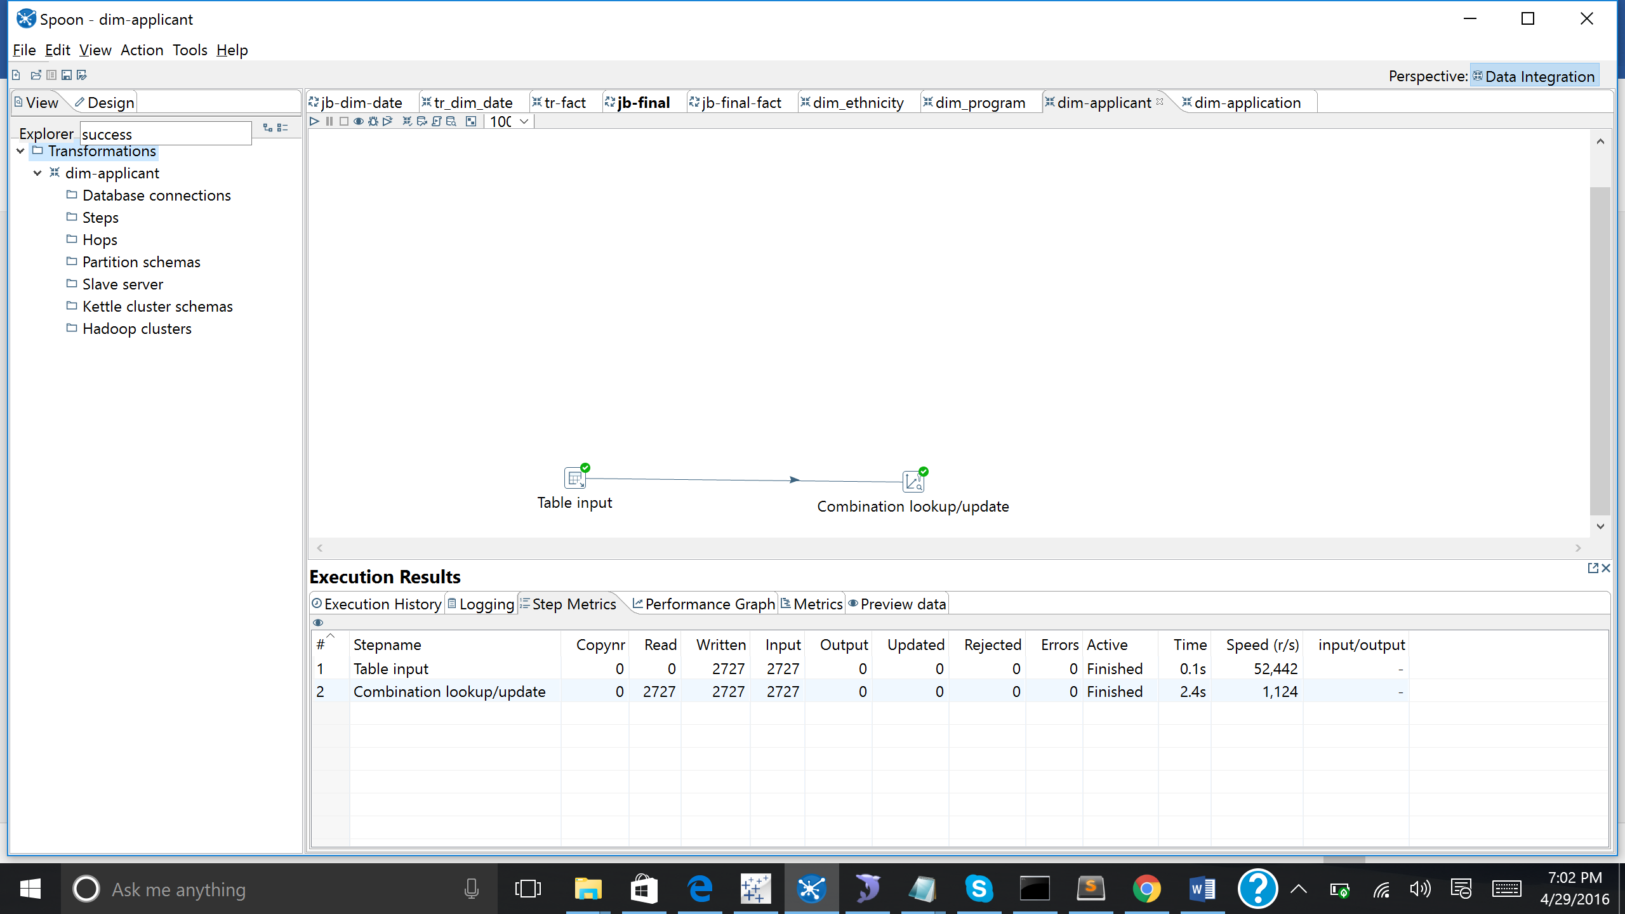

Created Transformation for dim_application

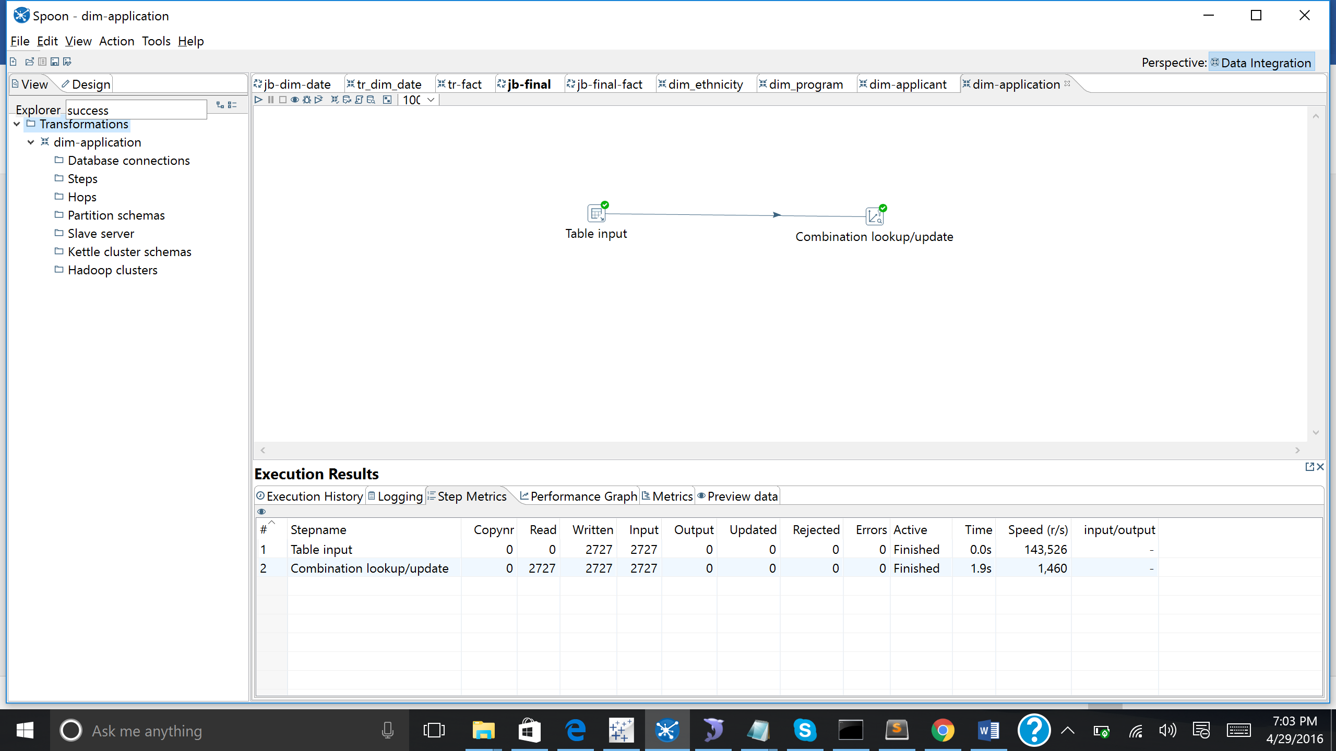

Created Transformation for dim_program

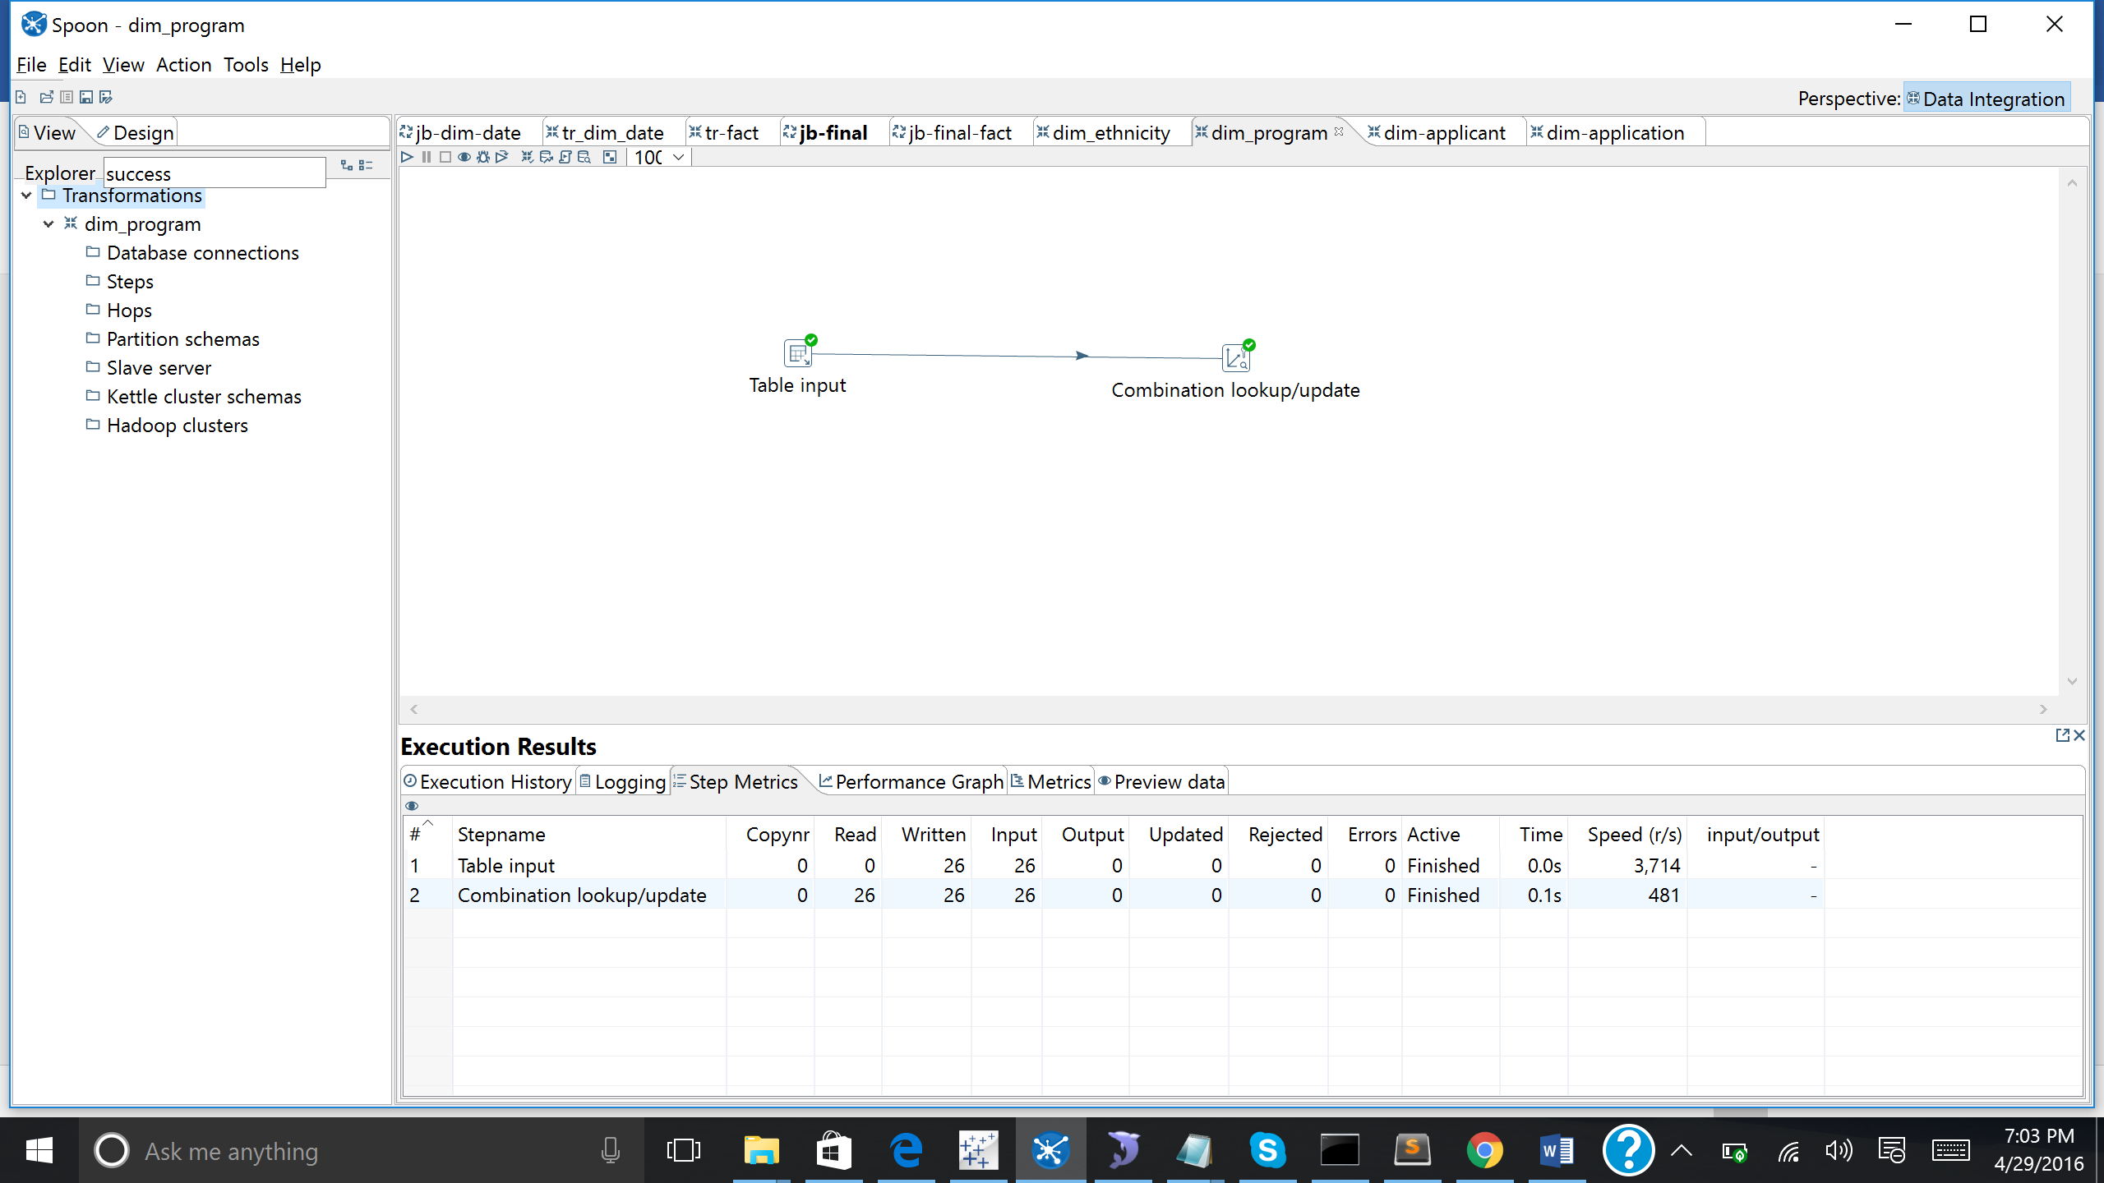

Created Transformation for dim_ethnicity

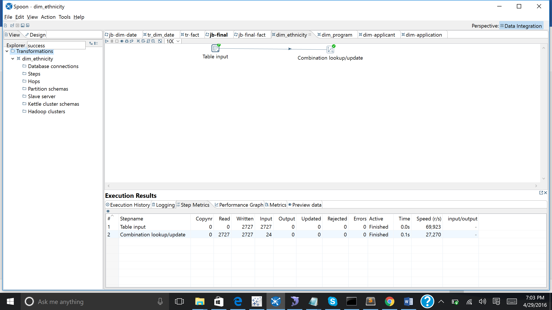

Created Transformation for dim_date

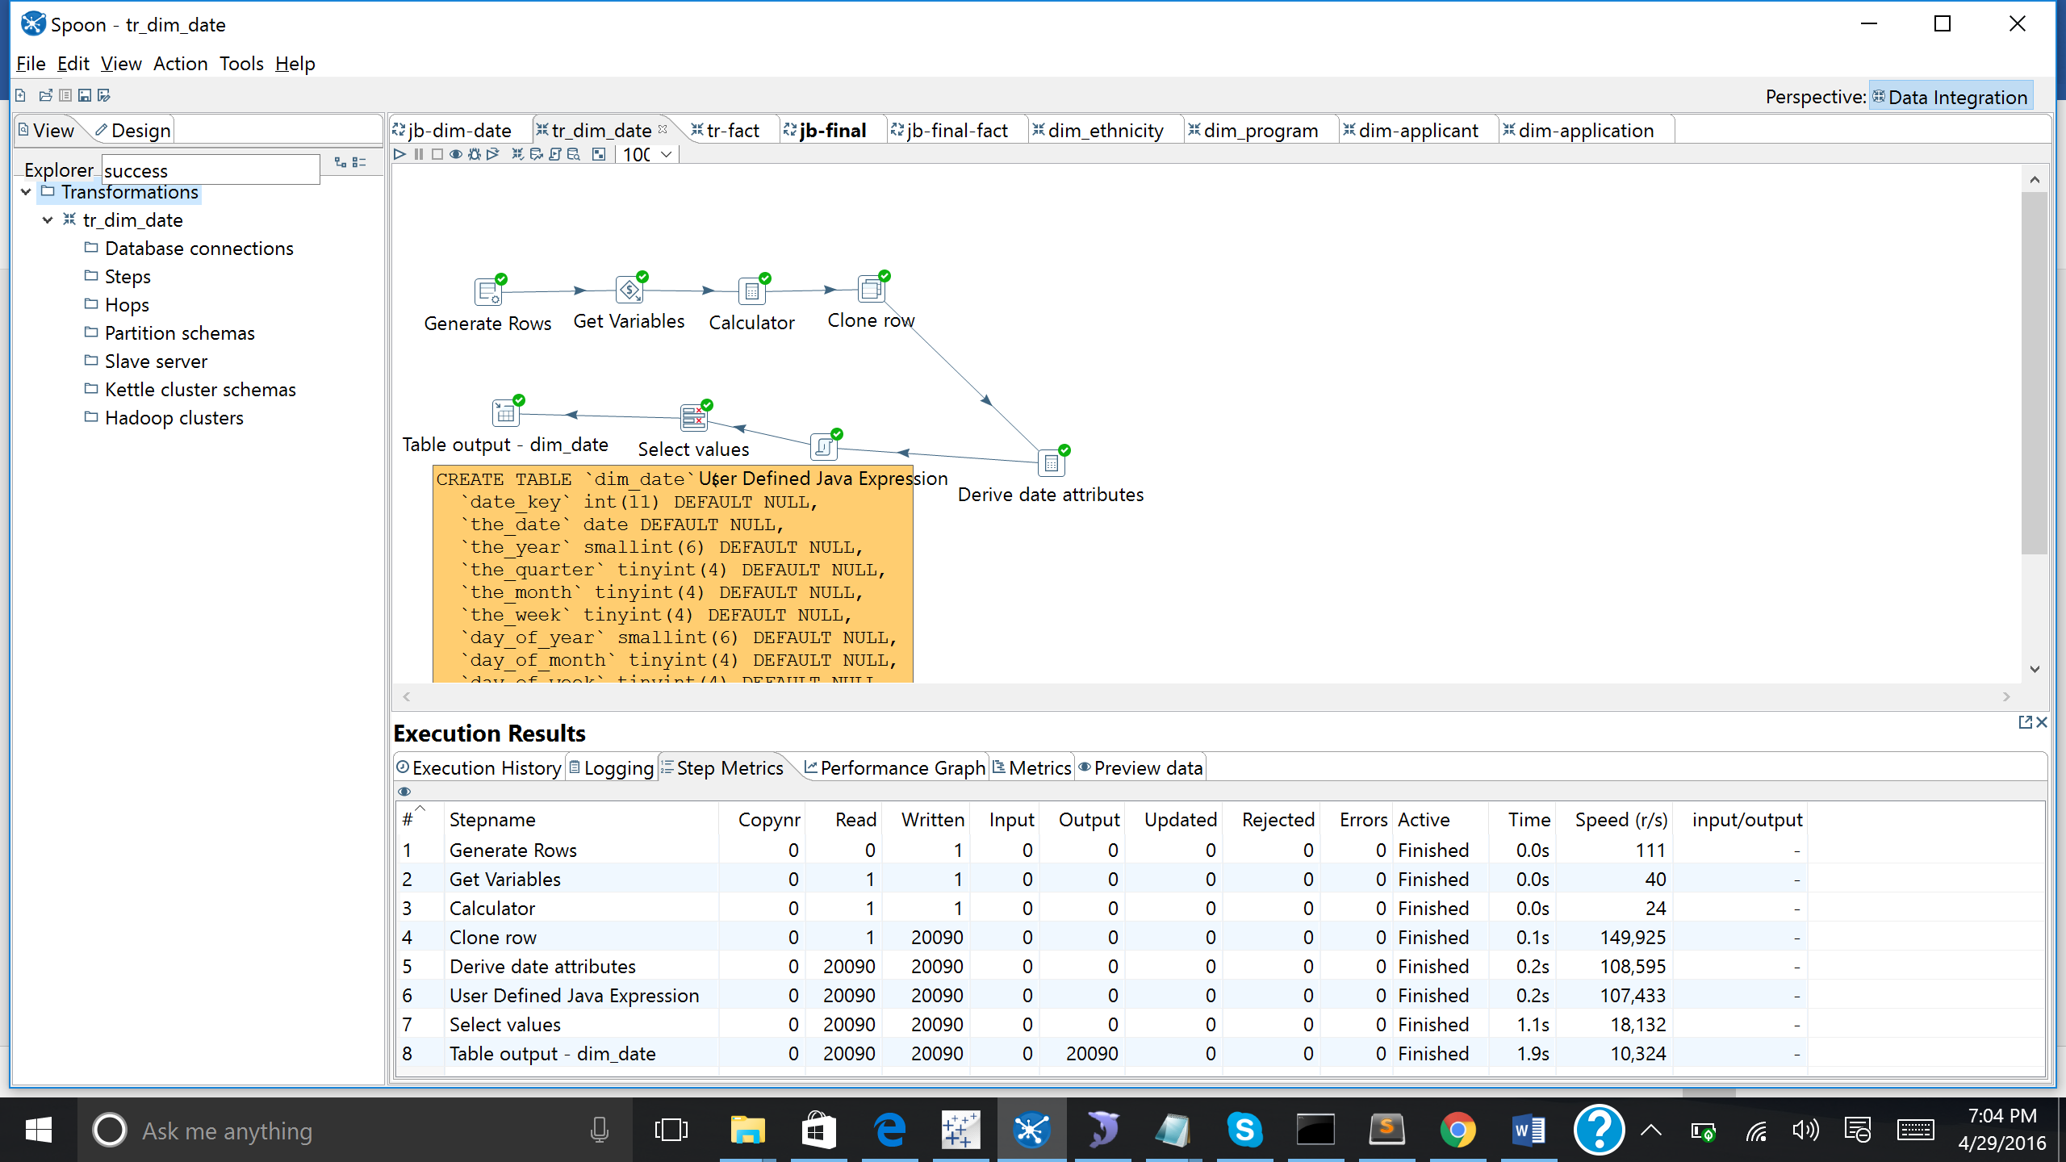

Created transformation for the fact_application1 by retrieving the keys from all the tables.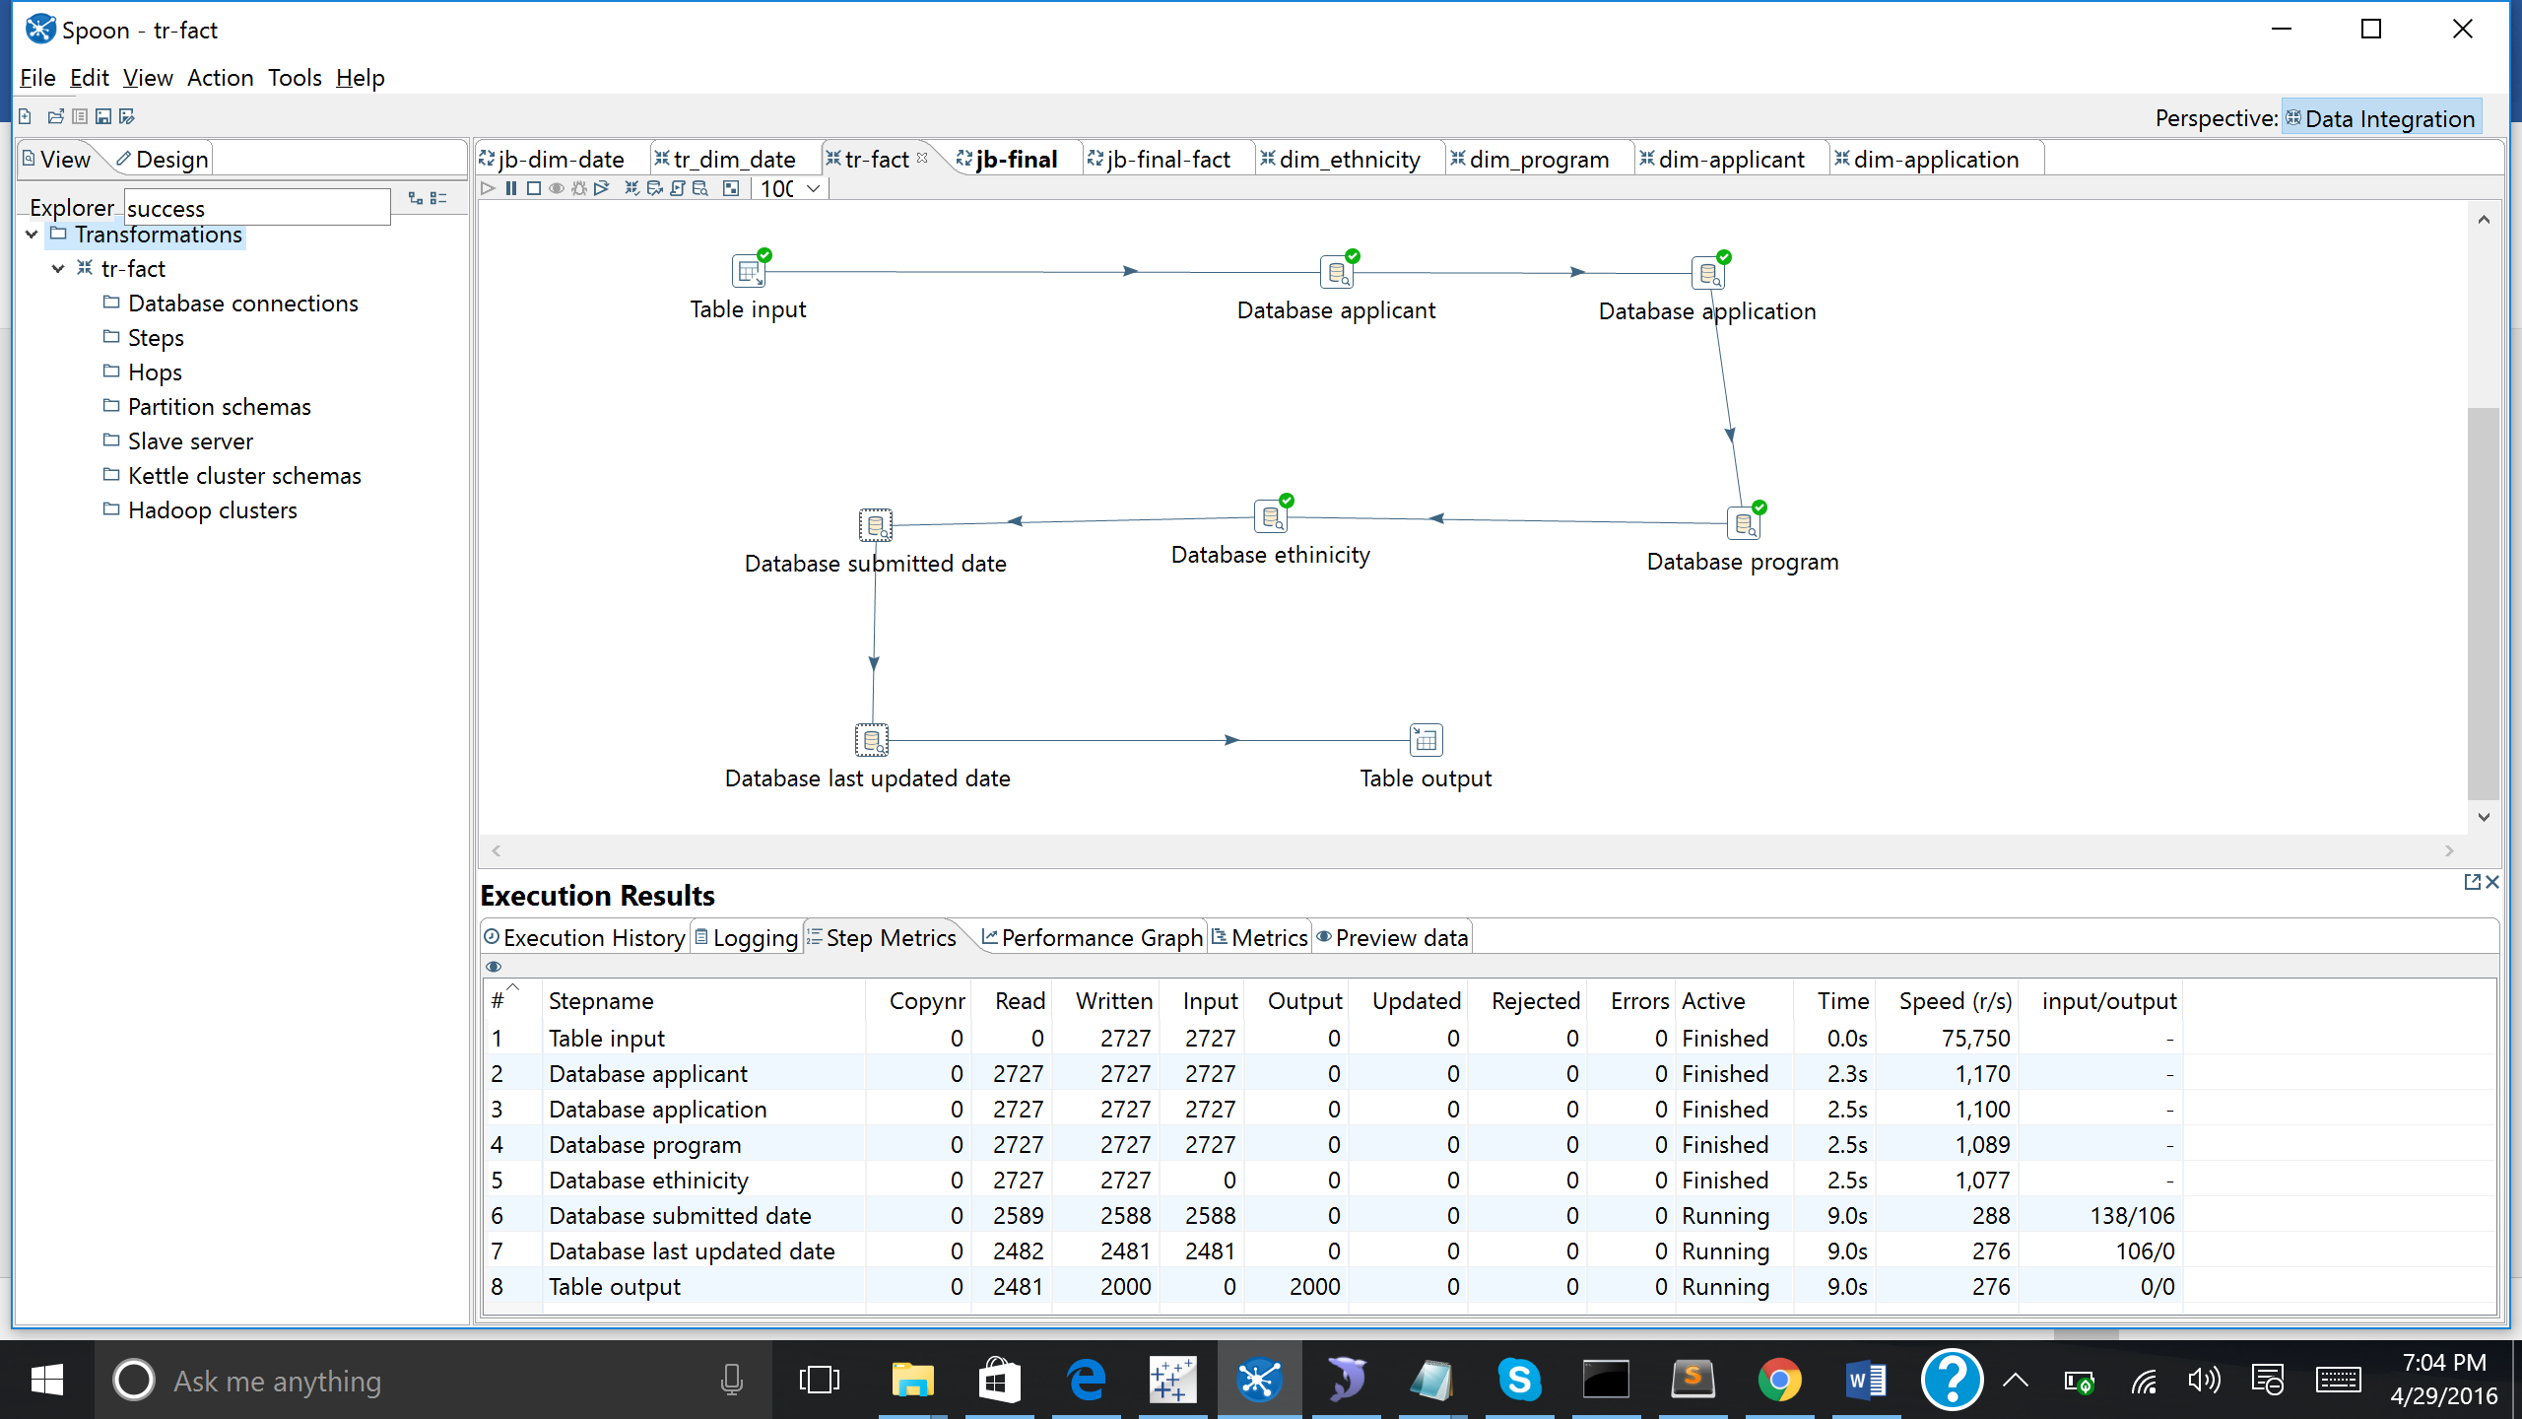

Running the job for all the transformations

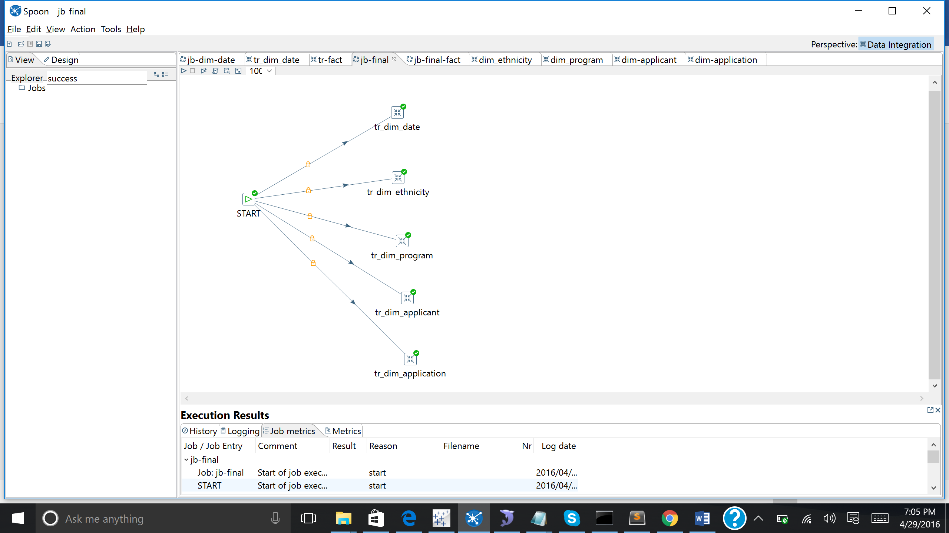

Running the final and the data is inserted into the Fact_table:

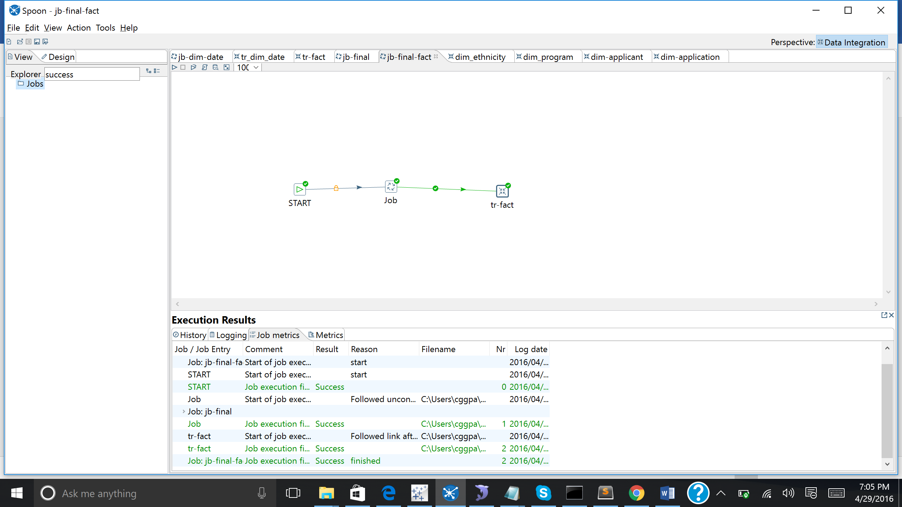

Data in the fact_Table:

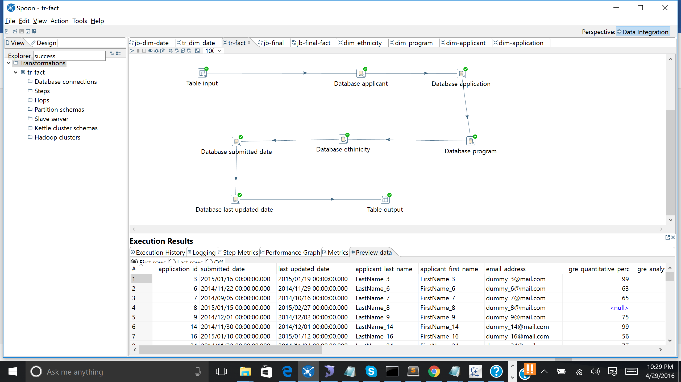

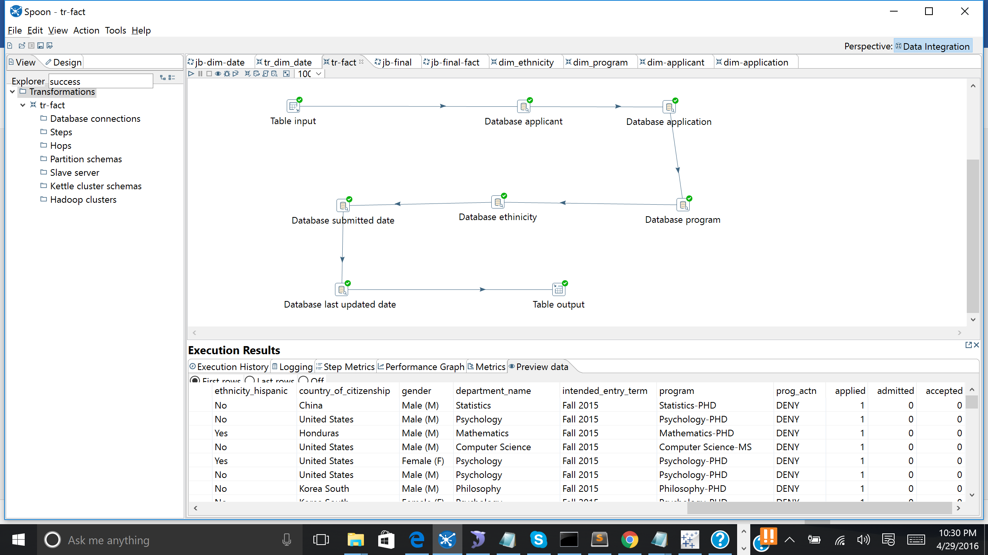

**Data inserted into the Tables after Transformation:**

Data got inserted into the table after running the transformation dim_applicant

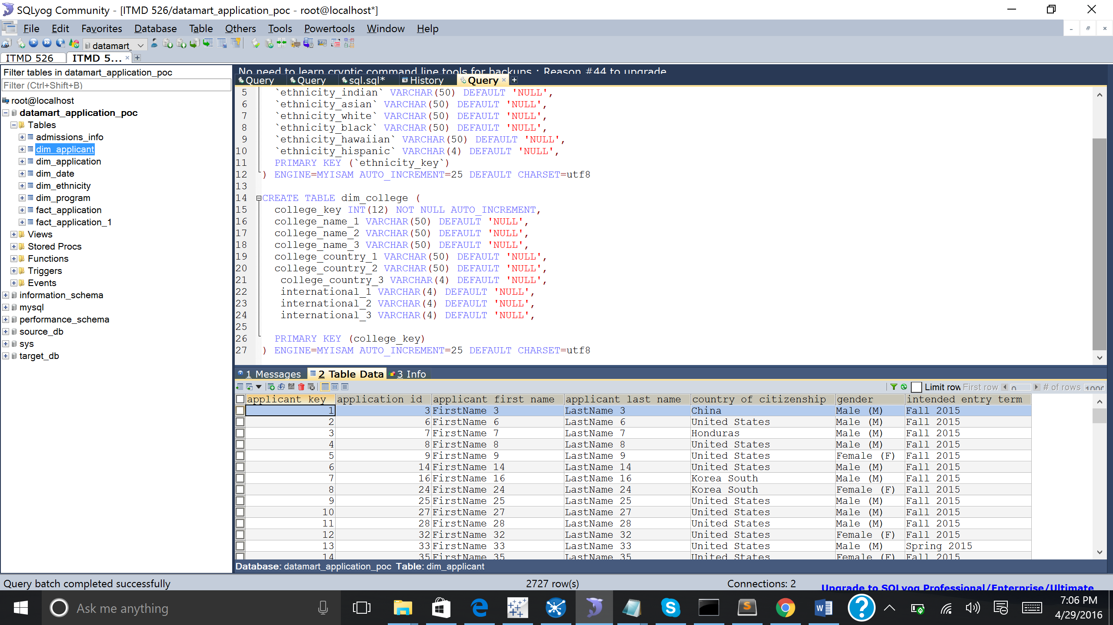

Data got inserted into the table after running the transformation dim_application

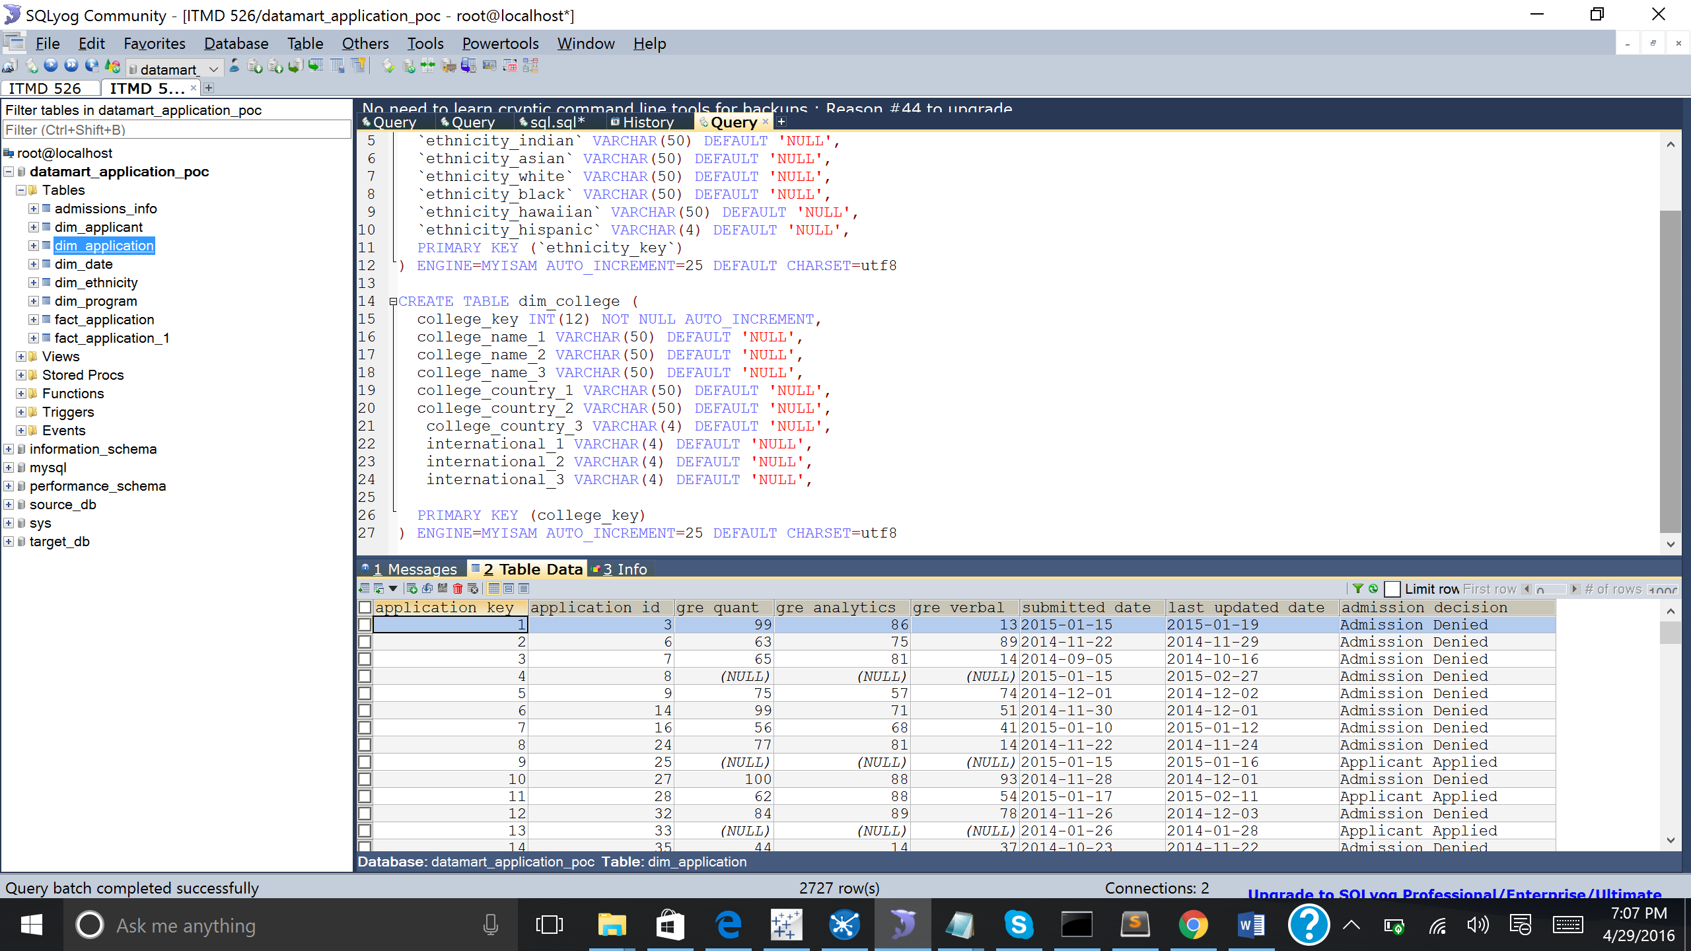

Data got inserted into the table after running the transformation dim_date

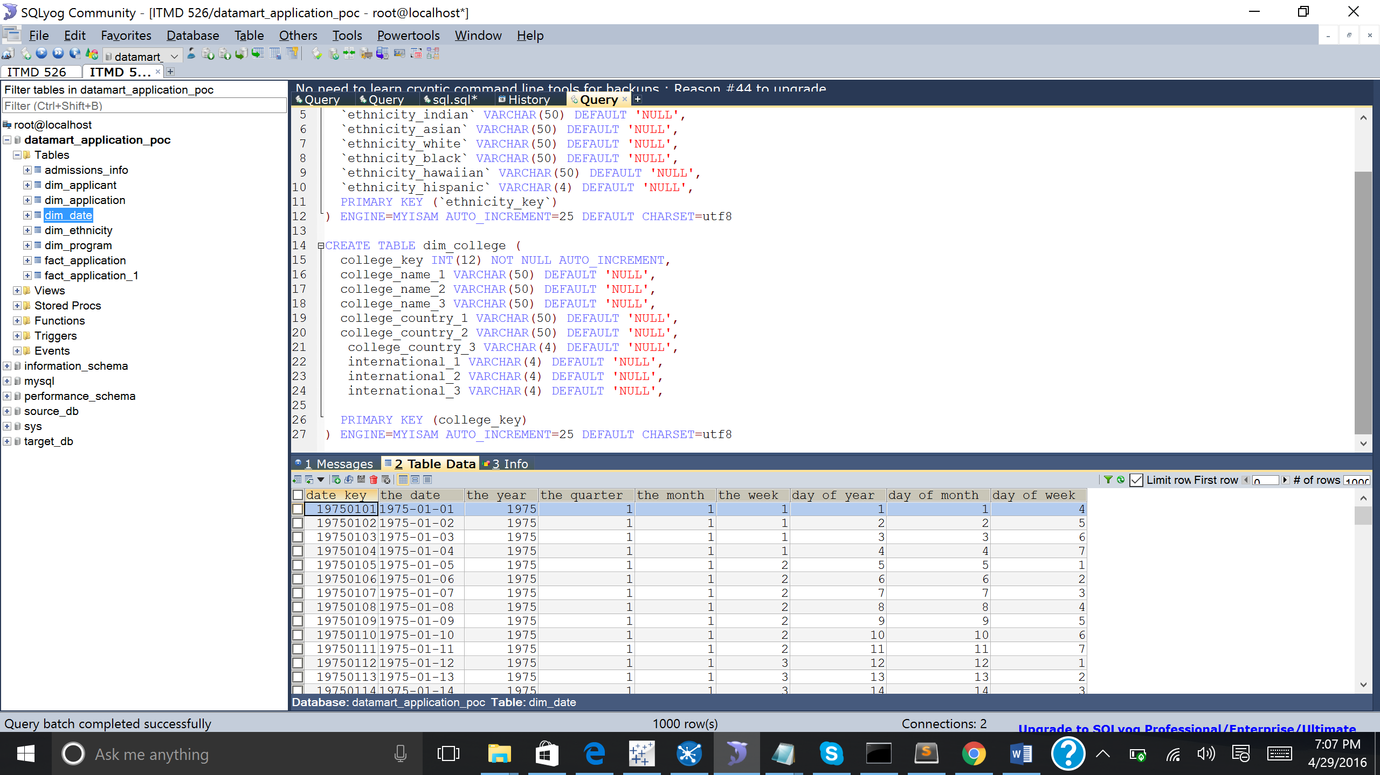

Data got inserted into the table after running the transformation dim_ethnicity

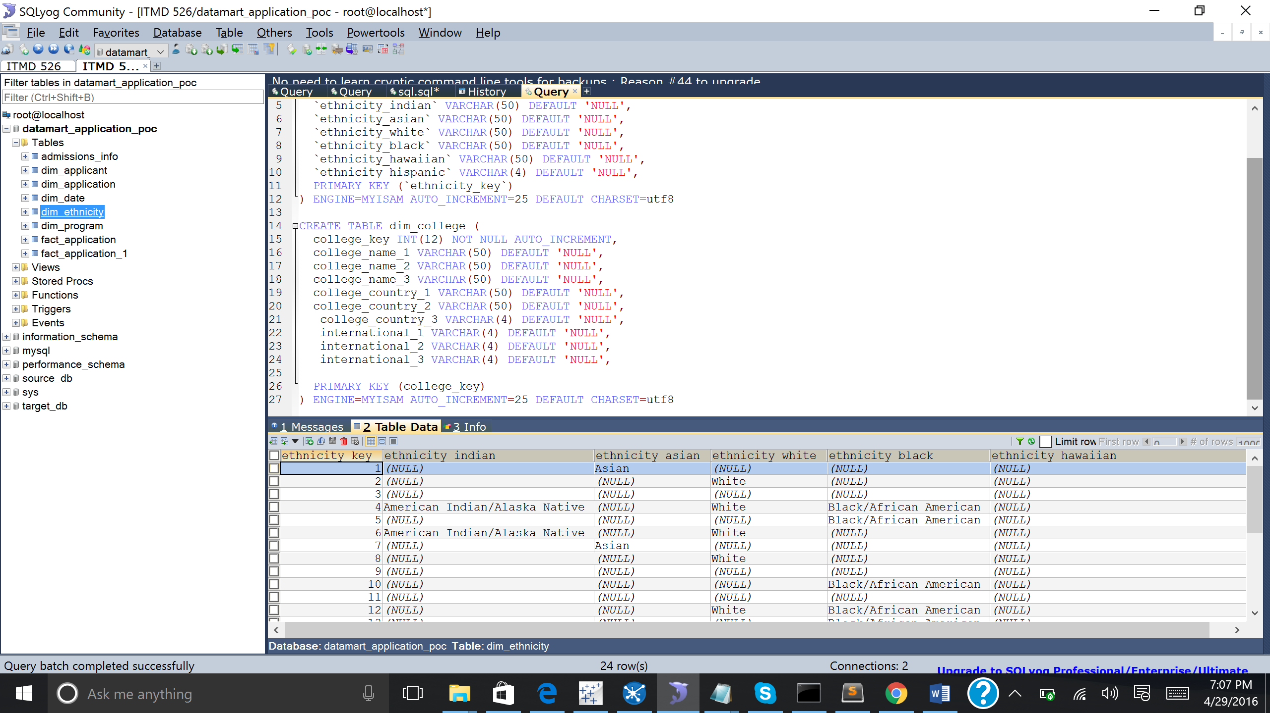

Data got inserted into the table after running the transformation dim_program

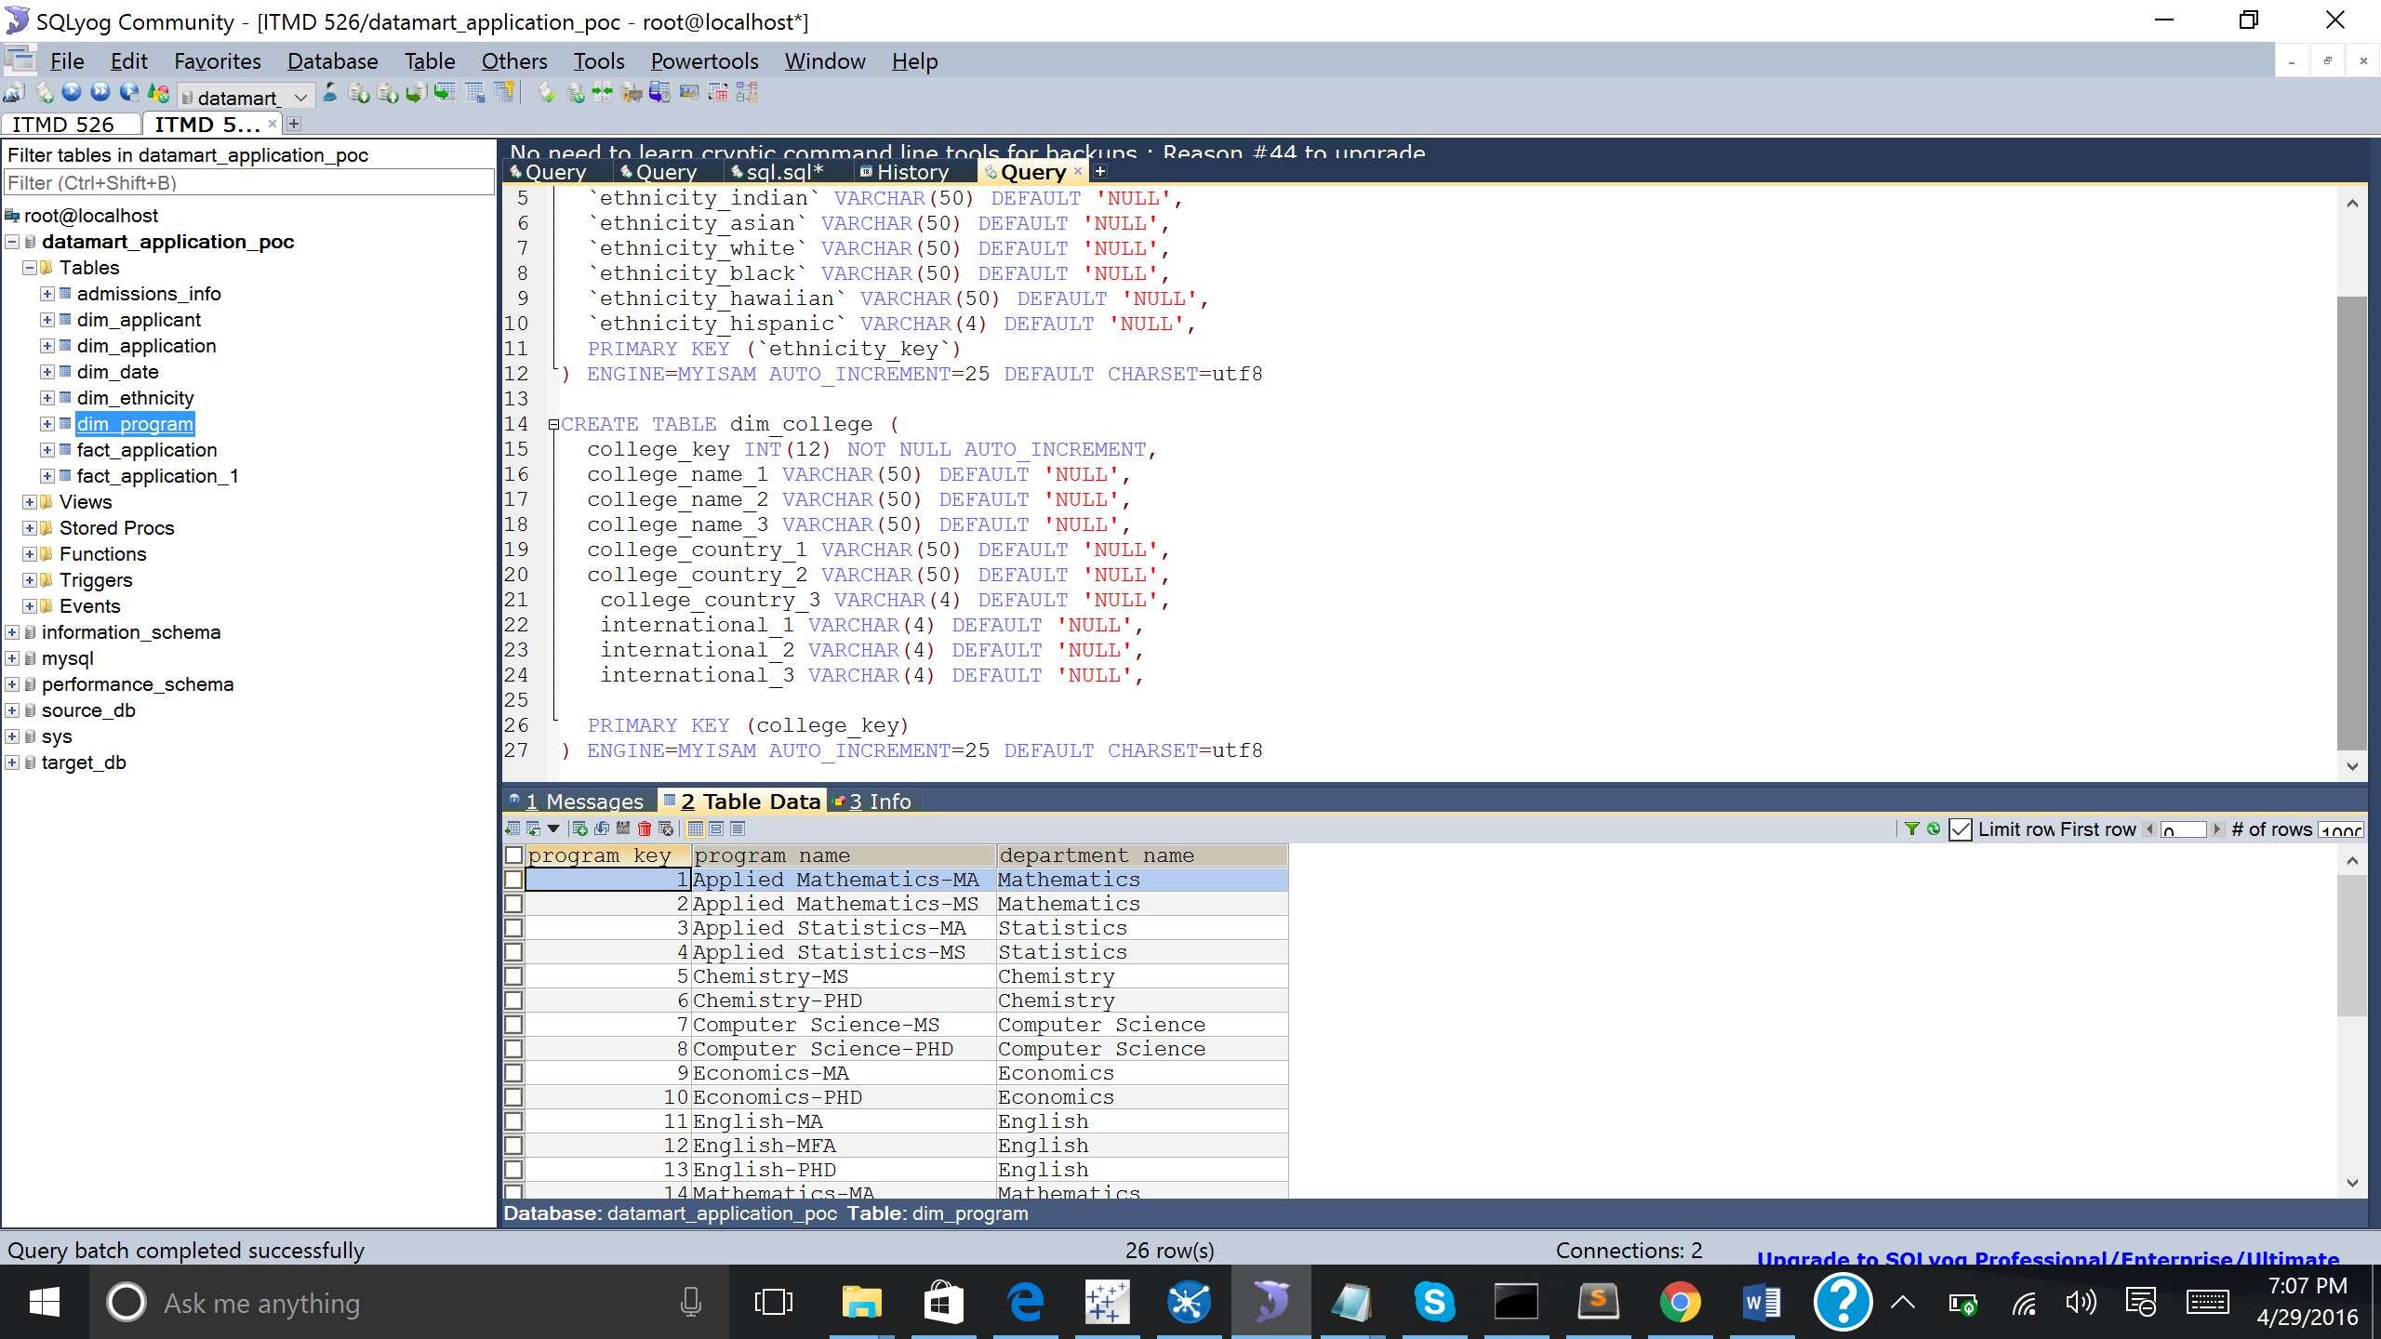

Data got inserted in the Bridge table (did not perform any transformation)

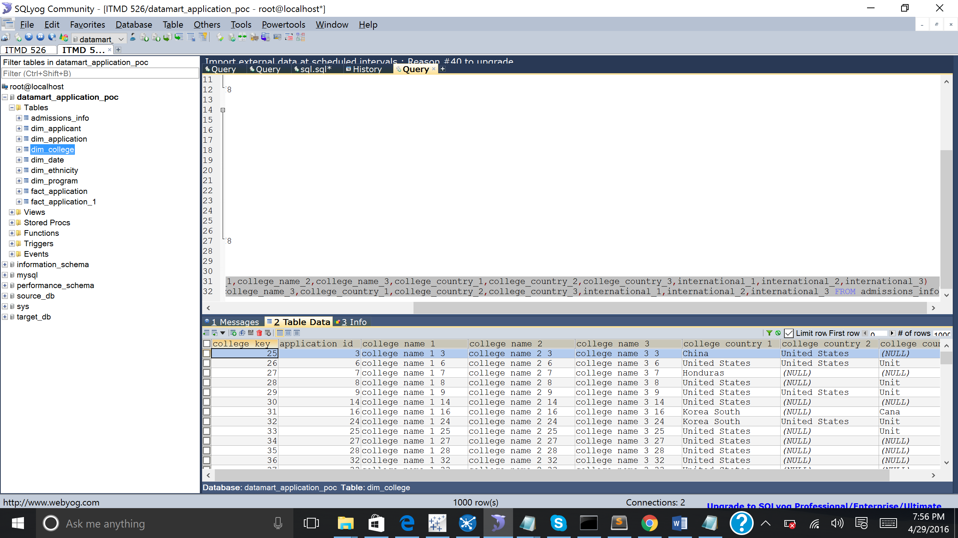

**Analysis and Reporting performed in tableau 9.3**

**Average GRE Analystics scored of five countries.**

Below shows the average GRE Analytics score of five countrie i.e., Canada, China, Germay, India and United States. It is seen that china has the highest average GRE analytics score of 91.92 followed by India. Canada has the least GRE Analytics score.

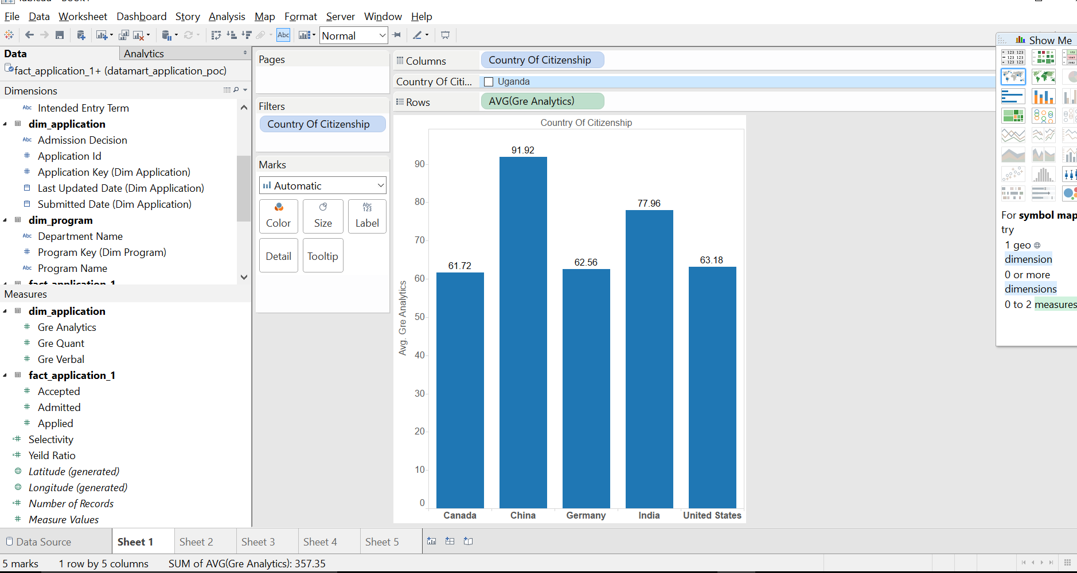

**Number of admits received for five countries**

Below shows the number of admits given to the students belonging to five different countires. It is seen that students from United States were given the most admits i.e., 201 followed with China (67), India (32), Bangladesh (3) and Mexico (1) which is been the least.

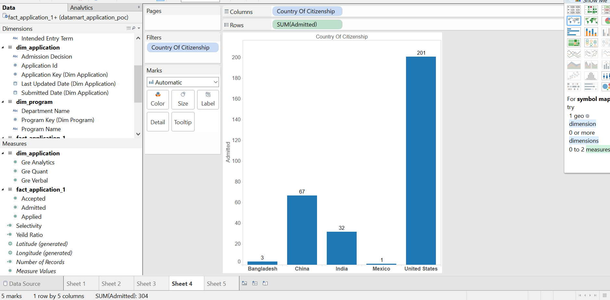

**Program name with the highest number of applications received:**

Below figure shows the students applied to five different program for MS program. It is seen that computer science MS has the highest number of applications received with count of 452. Mathematics-MS has the least number of applications received when compared with the other courses i.e., Computer Science, Applied Mathematics, Chemistry and physics.

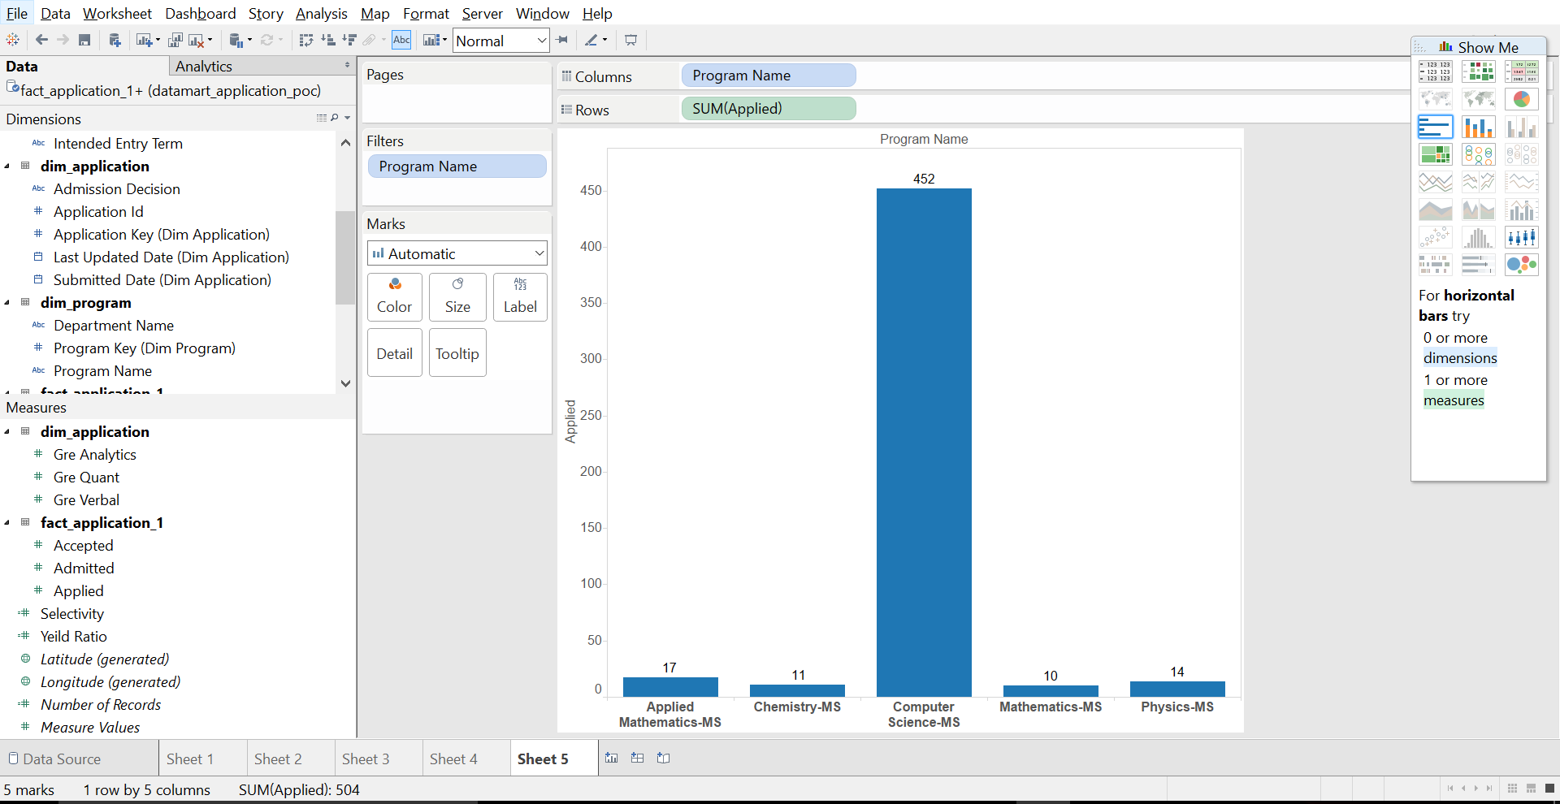

**Highest number of admissions received/given for a department:**

Below figure shows the admissions given to students by five different departments i.e., Chemistry, Computer Science, Mathematics, Neuroscience and Statistics. Chemistry department has given many admits when compared with the other departments. The chemistry department has 96 admits and Statistics has 20 which is the least.

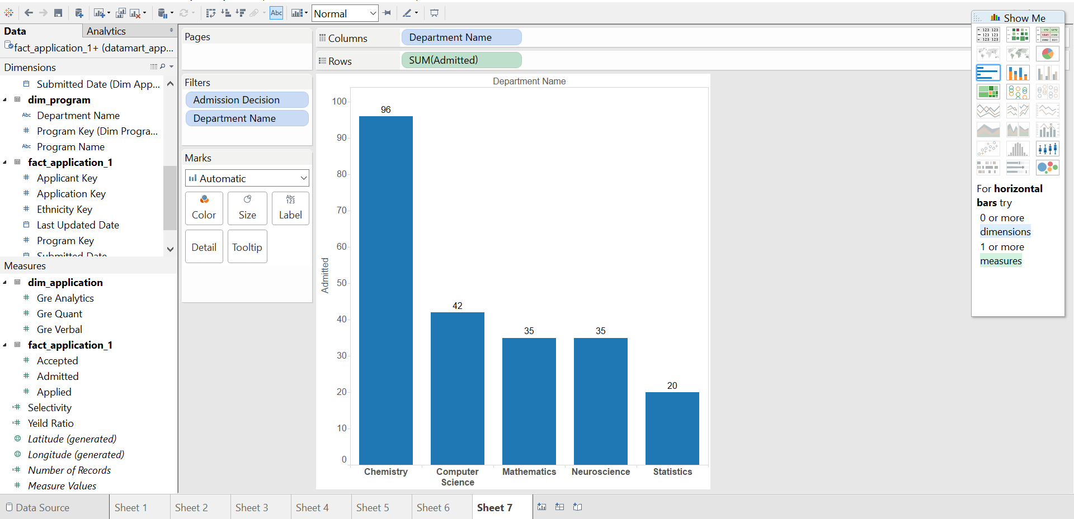

**Number of applications received for five departments:**

Below shows the number of students applied to five different departments i.e., Chemistry, Computer Science, English, Neurosciences and Statistics. Computer Science department has the highest applications applied by the student i.e., 579 followed with Statistic (304), Chemistry (237), English (242) and Neuroscience being the least (162)



**Two Calculated measured in the BI Application Layer:**

**Yield Ratio: Number of Accepted/Number of Admitted.**

Below shows the yield ratio for the five countries i.e., Bangladesh, China, India, Malaysia and United States. It is seen that yeild ratio is one for the country Bangladesh and least for Canada.

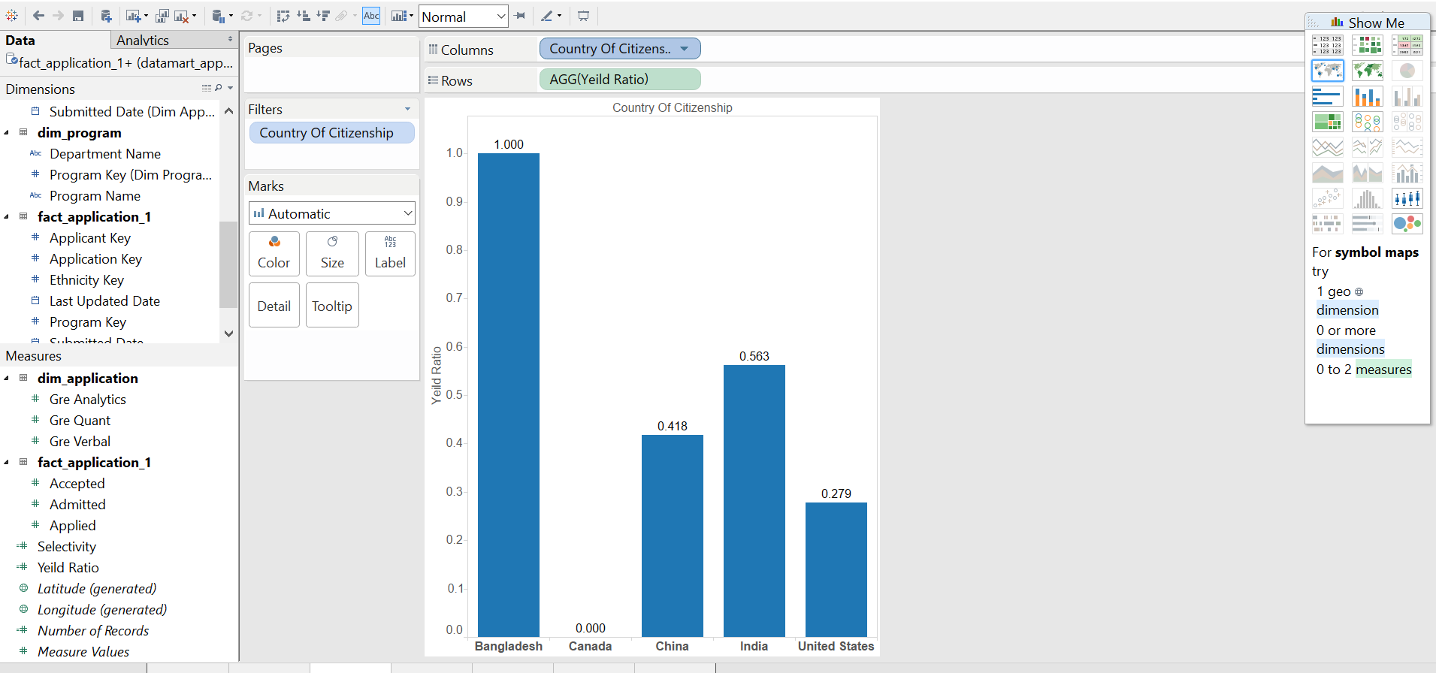

**Selectivity: Number of Admitted/ Number of Applied.**

Below shows the selectivity plotted against five different countries i.e., Bangaladesh, China, India, Mexico and United States. We can see that Bangladesh has the highest number of selectivity i.e., 27.27 followed with United States and least China

